How to Register
- Go to https://www.mandurah.wa.gov.au
- Click on Online Services
- Click apply for it
- Click on Don’t have an account?

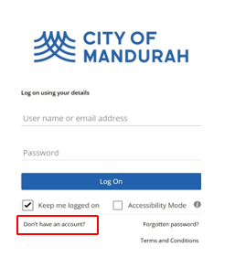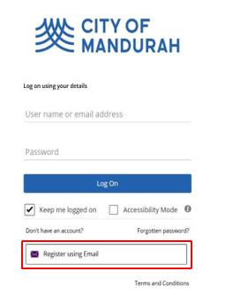
5 Click “Registering Email”


QUICK REFERENCE GUIDE

- Complete the following questions

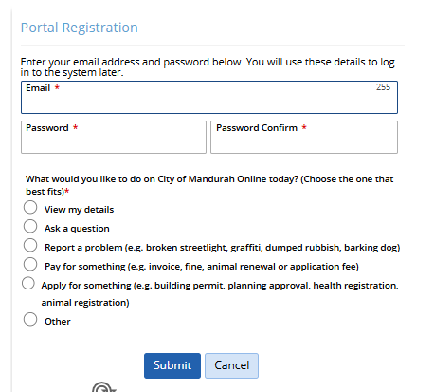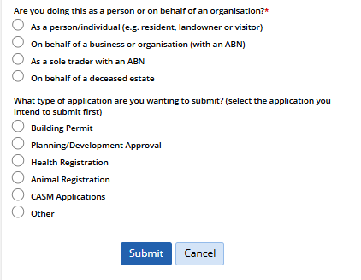

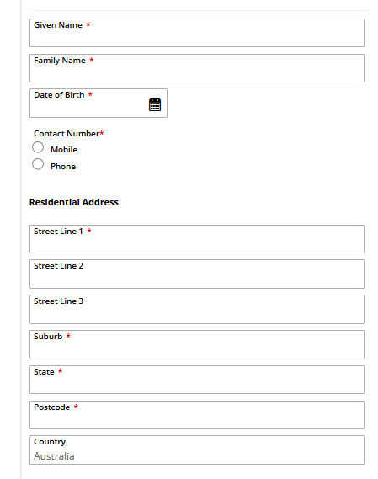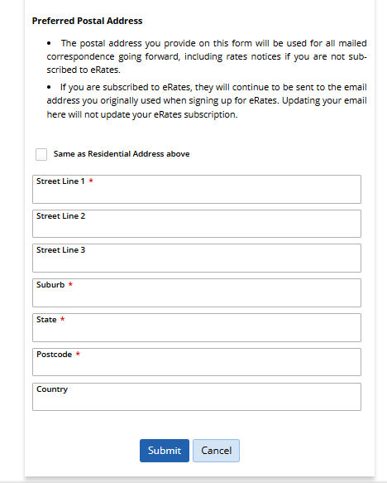

Once completed and and submitted you will receive and message
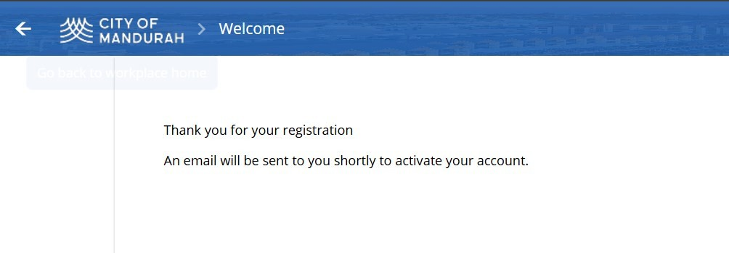

7/ Check your email for a verification email. Please also check junk/spam folder.
Click “HERE “to verify your email (as per below)
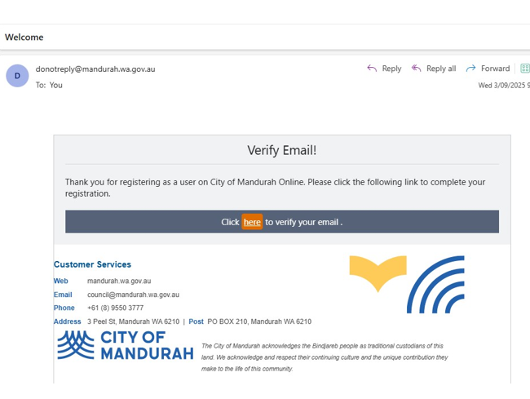

Accept the terms and conditions
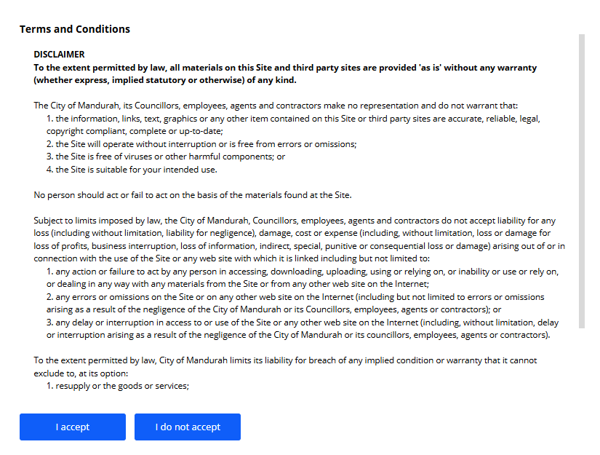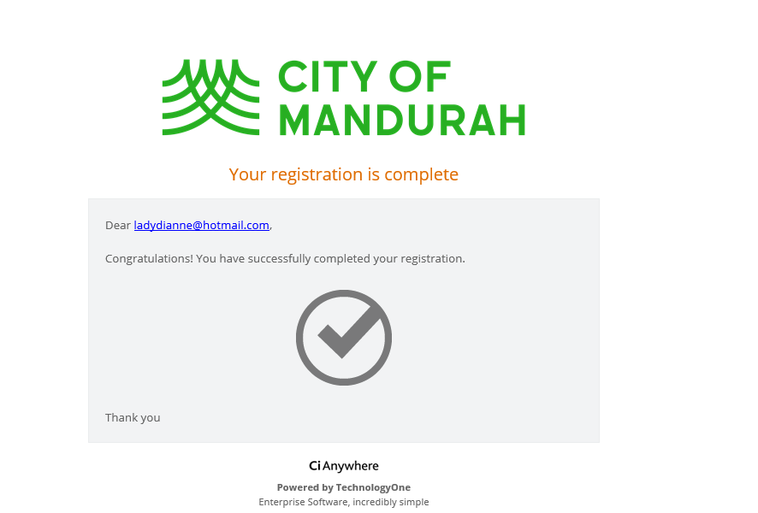
Conformation email – Your registration is complete

Please login using your details
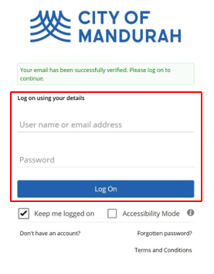
8/ Two Factor Authentication:
You will be prompted to setup Two Factor Authentication- this is mandatory. There are three methods available to use:
- Authenticator App
- Email Link
- Email Code (Best option)Click okay
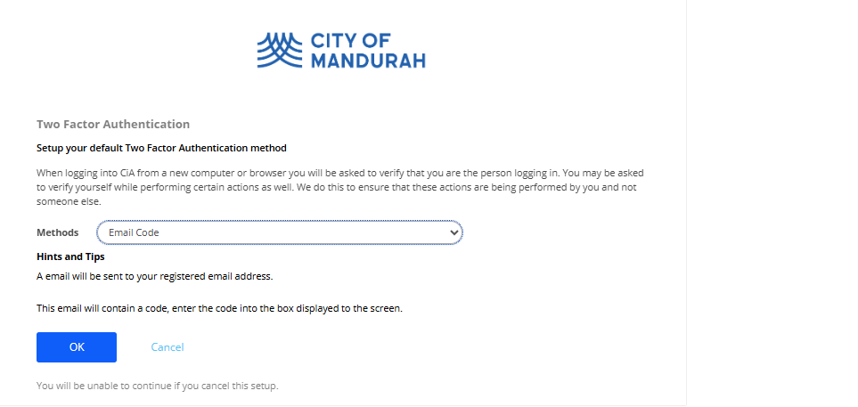
Check your email for the verification code
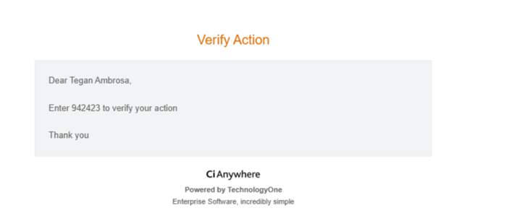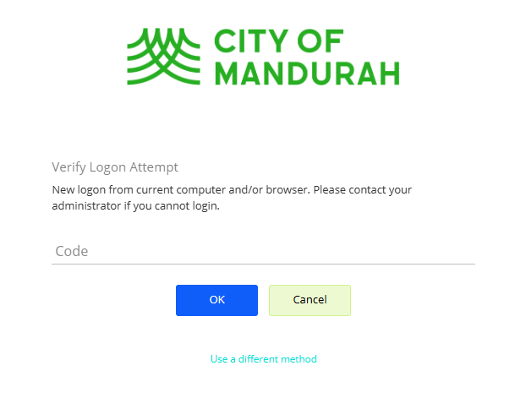
enter it in the section above. - Okay

Check your email for the verification code, then enter it in the section above. - Okay
Now you are ready to access the portal and your home screen will look like this
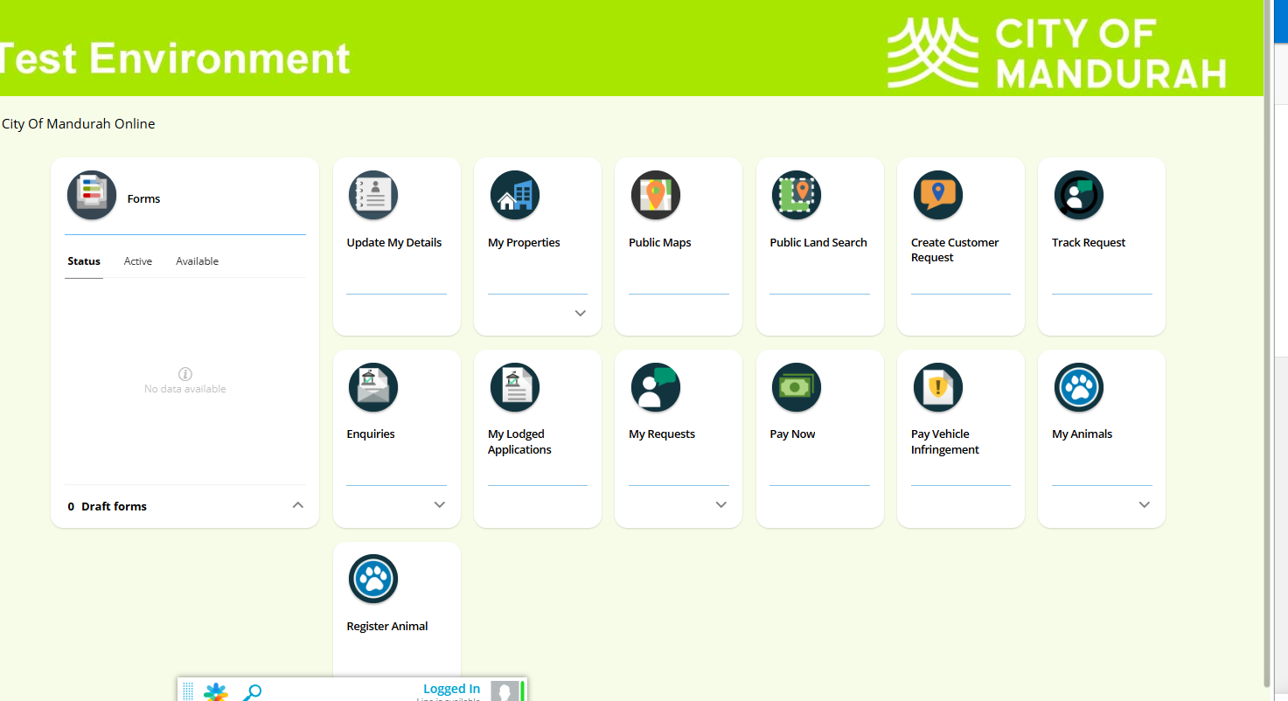
How to lodge an application:
- Click on Tile enquires
- By clicking on the arrow located by the circle in green will expand the tile to make larger

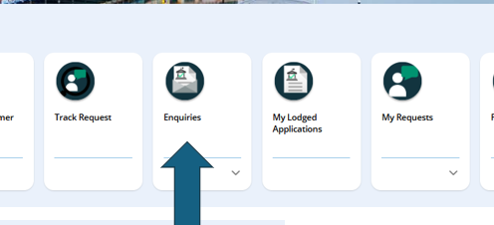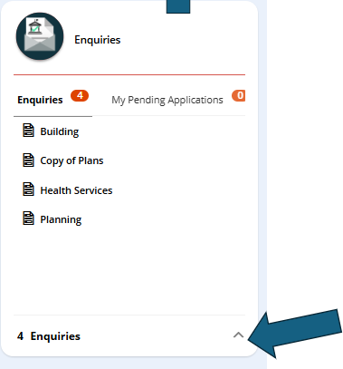
By enlarging the tile, you will be able to see any application pending
(Not Completed)

Find the application that you require and click on start button- complete the application answering all question and add documents as required and submit.

